Jquery

<script src=”jquery-1.11.3.js”></script>

<script src=”file////c::/Users/Rajesh”/Desktop/jquery-1.11.3.js”></script>

<script type=”text/javascript”>

$(document).ready(function () {

…………….

……………..}

);

$(document).ready(func_name());

$(funcname());

jquery(funcname()); //u can use any syntax for document ready

</script>

whatever u doing in jquery, it should comes under $()ready(func);

$(window).load() - load after all images, files loaded

$(document).ready() -load after dom loaded, not wait for images files

different between class and id- know it

## **Selectors: 1.**Basic 2.Hierarchy 3.Attribute 4.Form

### 1.Basic

Element-$(“h1”) $(“h3”)

Id -$(“#idname”)

Class- $(“.classname”)

Universal- $(“*”)

Multiple(“h1,h2,h3”)

### 2.Hierarchy

child –used to select first children of parent $(“parent>child”)

decendant- select all which are decendant of ancestor $(“ancestor descentant”)

next adjacent- select which are next to previous $(“element+next adjacent”)

next siling- select siblings of current element $(“element~sibling”)

ex.

<script>

$(document).ready(function(){

$(“div>h1”).click(function(){

alert(“hii clicked”); //if u click “welcom” it show alert if

}); //u click “hello” it not show alert becz welcome is direct child of div

$(“div>h1”).click(function(){

alert(“hii clicked”); //it show alert becz both h1 is decendant of div

});

$(“div +h3”).click(function(){ //if we click h3 alert will execute becz it is next to div

alert(“hii clicked”);

});

$(“h4 ~h3”).click(function(){ //if h4 h3 are same children it get alert

alert(“hii clicked”);

});

});

</script>

</head><body>

<div>

<h1>welcome</h1> <h2>always</h2>

<h3>click</h3>

</div>

<h3>goodmorning</h3>

<div>

<span>

<h1> hello</h1>

</span>

</div>

</body>

### 3.Attribute Selector:

|  |  |  |
| --- | --- | --- |
| Attribute | $(“h1[id]”) | select element based on attribute |
| Equals | $(“h1[id=tagname]”) | select element based on value |
| Not Equals | $(“h1[id!=tagname]”) | select element which are not equal |
| Starts with | $(“h1[id^=’tag’]”) | select element start with given value |
| Ends with | $(“h1[id$=’name’]”) | select element ends with given value |
| Contains | $(“h1[id*=’tag’]”) | select element which contain part of given value |
| Contains word | $(”[id~=’tagname’]”) | select element which contain exactly same value |

### 4.Forms Selector

whenever the type is selected, it will perform following functions

1.<input type=”text”>hii</input> $(“:text”).click(function(){ …………………….});

2.<input type=”button”></input> $(“:button”).click(function(){…………………..});

3.<input type=”submit”>hii</input> $(“:submit”).click(function(){ …………………….});

4.<input type=”reset”>hii</input> $(“:reset”).click(function(){ …………………….});

5. <select multiple><option>hii</option> <option>hello</option></select> $(“option:selected”).click(function………….});

6. fooball<input type=”checkbox”/>cricket<input type=”checkbox”/>$(“input:checked”).click(function(){ ……………….});

## Effercts:

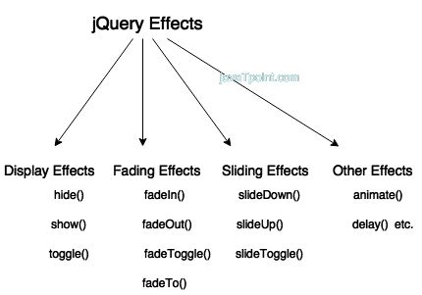

<input type=”button” onclick=”hideme”/> ||function hideme(){$(“#head1”).hide(2000);}

<input type=”button” onclick=”show me”/>||function showme(){$(“#head1”).show(“slow”);}

<input type=”button” onclick=”toggleme”/>||function toggleme(){$(“#head1”).toggle();}

<input type=”button” onclick=”fadeoutme”/> ||function fadeoutme(){$(“#head1”).fadeOut();}

<input type=”button” onclick=”show me”/>||function fadeinme(){$(“#head1”).fadeiIn();}

<input type=”button” onclick=”toggleme”/>||function fadetoggleme(){$(“#head1”).fadeToggle(5000);}

<input type=”button” onclick=”fadetome”/> ||function fadetome(){$(“#head1”).fadeTo(2000,0.4);}

<input type=”button” onclick=”slidedownme”/> ||function slidedownme(){$(“#head1”).slideDown(2000);}

<input type=”button” onclick=”slideupme”/>||function slideupme(){$(“#head1”).slideUp(“slow”);}

<input type=”button” onclick=”slidetoggleme”/>||function slidetoggleme(){$(“#head1”).slideToggle();}

<input type=”button” onclick=”stopme”/> ||function stopme(){$(“#head1”).stop();}

<input type=”button” onclick=”animateme”/> ||function animateme(){$(“#head1”).animate({left:’900px’,fontsize:’20px’},3000);

$(“#head1”).animate({bottom:’-400px’,fontsize:’120px’},2000);}

## Filters:

It is used to filter set of matched elements to match selector

### Basic Filters:

#### First- used to select first element in page $(“:first”)

#### Last- used to select last element $(“:last”)

#### Equals- used to select element which index value $(“:eq(index)”)

#### Not- used to select element which do not match specified element $(“:not(selector)”)

#### Even- used to select which has even index $(“:even(index)”)-

#### Odd- used to select which has odd index $(“:odd(index)”)

#### Greate than- used to select which has index greater the specified index $(“:gt(index)”)

#### Lesser than-used to select which has index less than specified index $(“:lt(index)”)

#### Header- used to select all header from h1 to h6 $(“:header”)

|  |  |
| --- | --- |
| <body>  <div style=”background-color:lightblue”>  <h1 id=”head1”>vanakam</h1>  <h1>namaste<h1>  <h1>namaskar<h1>  </div> | $(document).ready(function(){  $(“h1:first”).click(function(){alert(“vanakam is clicked”);});  $(“h1:last”).click(function(){alert(“namaskar is clicked”);});  $(“h1:eq(1)”).click(function(){alert(“namaste is clicked”);});  $(“h1:not(#head1)”).click(function(){alert(“vanakam is not clicked”);});  $(“:header”).click(function(){alert(“Header element is clicked”);});  $(“h1:gt(1)”).click(function(){alert(“namaskar is clicked”);});  $(“h1:lt(1)”).click(function(){alert(“vanakam is clicked”);});  $(“h1:even”).click(function(){alert(“vanakam and namaskar is clicked”);});  $(“h1:odd”).click(function(){ alert(“namaste is clicked”);});  }); |

### Child Filters:

#### First child –used to select first child of parent $(“:first-child”)

#### Last child- used to select last child of parent $(“:last-child”)

#### Nth child- used to select nth child of parent $(“:nth-child(n|even|odd)”)

#### Only child- used to select which has only child of parent $(“:only-chlid”)

|  |  |
| --- | --- |
| <body>  <div class=”D1” >  <h1 id=”head1”>vanakam</h1>  <h1>namaste<h1>  <h1>namaskar<h1>  </div> | $(document).ready(fucntion(){  $(“.D1 h1:first-child”).click(function(){ alert(“vanakam is clicked”);});  $(“.D1 h1:last-child”).click(function(){ alert(“namaskar is clicked”);});  $(“.D1 h1:nth-child(even)”).click(function(){ alert(“namaste is clicked”);});  $(“.D1 h1:only-child”).click(function(){ alert(“this will not display, it is not only child”);});  }) |

### Content Filters:

#### Contains- used to select element that contain specified data $(“:contains(text)”)

#### Empty- used to select which does not have any child or tect

#### Has- used to select which has atleast one element matching selector $(“:has(selector)”)

#### Parent- used to select whichc has atleast one child element $(“:parent”)

|  |  |
| --- | --- |
| <body>  <div class=”D1” >  <h1 id=”head1”>good morning</h1>  <h1>good night<h1>  <h1>good afternoon<h1>  <h2></h2>  </div> | $(document).ready(function(){$(“.D1 h1:contains(good)”).click(function(){alert(“good is clicked”)});$(“.D1 h2:empty”).click(function(){alert(“it is empty”)});$(“.D1:has(h1)”).click(function(){alert(“D1 has H1”)};$(“.D1:parent”).click(function(){alert(“D1 is parent of h1”);)};}); |

### Visisbility Filters:

#### Hidden- select all element which are hidden $(“:hidden”) <display:none> // intha elements matum click pana matum work aagum

#### Visible- select all element which are visible $(“:visible”)

# Events:

## Click $(“selector”).click(function()); response when user click an element

## DoubleClick $(“selector”).dbClick(function());

## MounseEnter $(“selector”).mouseEnter(function());

## MouseLeave $(“selector”).mouseLeave(function());

## MouseOver $(“selector”).mouseOver(function());

## MouseOut $(“selector”).mouseOut(function());

## MouseDown $(“selector”).mouseOut(function());

## MouseUp $(“selector”).mouseOut(function());

## MouseMove $(“selector”).mouseOut(function());

## Hover $(“selector”).mouseOut(function()); when cursor enter and leaves an element

## Focus $(“selector”).mouseOut(function()); if cursor active to form

## Blur $(“selector”).mouseOut(function()); if cursor unactive to form

## Keyup $(“selector”).mouseOut(function());

## Keydown $(“selector”).mouseOut(function());

## Keypress $(“selector”).mouseOut(function()); response when user press or release key

## Bind $(“selector”).mouseOut(function()); one or more event handlers attached to element

# HTML dom Manipulation:

## Basic

### Addclass- used to add a style class .addclass()

### Hasclass- used to check whether given class exist or not .hasClass()

### Removeclass- used to remove a class .removeClass() //if no paramter given it will remove all classes

|  |  |
| --- | --- |
| <body>  <h1>vanakam</h1>  <h2>namaste</h2>  </body> | $(document).ready(function(){$(“h1”).click(function(){ $(“h2”).addclass(“c1 c2”);});$(“h1”).click(function(){ $(“h2”).hasclass(“c1 c2”);});$(“h1”).click(function(){ $(“h2”).removeclass(“c1”);});$(“h1”).click(function(){ $(“<h2>namaskar</h2>”).replaceAll(“h1”);});$(“h1”).click(function(){ $(“h1” ).replaceWith(“<h4>namaskar</h4>”) });}); }); |

## Replace methods

### Replace all- used to replace new content to all selected element $(content).replaceAll(selector)

### Replace with- used to replace the new content to only selected element $(selector).replaceWith(content)

## Insert methods:

### Insert inside:

#### Append- $(“selecter”).append(“content”) content will add at end

#### Appendto- $(“content”).appendTo(“selecter”) same as append, only syntax different

#### Prepend- $(“ selecter”).perpend(“content”) content will add at beginning

#### Prependto- $(“content”).prependTo(“selecter”) same as prepend only syntaxx different

#### Html: $(“ selecter”).html(“content”) used to set or get new HTML elements

#### Css: $(“ selecter”).css(“preoperty”:”value”) used to set or get new CSS elements

#### Text $(“ selecter”).text(“content”) used to set or get text inside html element

#### Values $(“ selecter ”).val(“content”) used to set or get value for selected elements

|  |  |
| --- | --- |
| <body> <div style=”background-color:yellow”>  <h1>muthu<h1>  </div>  </body> | $(document).ready(function(){$(“h1”).click(function(){ $(“h1”).append(“rajesh”);});$(“h1”).click(function(){ $(“h1”).appendTo(“rajesh”);});$(“h1”).click(function(){ $(“h1”).prepend(“sri);});$(“h1”).click(function(){ $(“h1”).prependTo(“sri”);}); $(“h1”).click(function(){ $(“h1”).html(“<b>name<b>”); });  $(“h1”).click(function(){ $(“h1”).text(“name”); }); }); |

### Insert around:

#### Wrap $(“ selecter”).wrap(“content”) used to wrap new elements around each specified element

#### WrapAll $(“ selecter”).wrapAll(“content”) used to wrap new elements around all specified elements

#### UnWrap $(“ selecter”).unwrap(“content”) used to unwrap existinf elements around specified element

#### WrapAll $(“ selecter”).wrapInner(“content”) used to wrap inner child content including tedxt around new element

|  |  |
| --- | --- |
| <body>  <h1>sri<h1>  <h1>rajesh<h1>  </body> | $(document.ready(function(){  $(“h1”).click(fucntion(){ $(“h1”).wrap(“<div></div>”);});  $(“h1”).click(fucntion(){ $(“h1”).wrapInner(“<p>muthu</p>”);});  $(“h1”).click(fucntion(){ $(“h1”).unwrap(“<p>muthu</p>”);});  $(“h1”).click(fucntion(){ $(“h1”).wrapAll(“<div> </div>”);}); }); |

### Insert outside

#### After $(“element”).after(“content”) insert content after specified content

#### InsertAfter- $(“content”).insertAfter(“selector”); //same operation as .after

#### Before $(“element”).before(“content”) insert content before specified content

#### InsertBefoe $(“content”).InsertBefore(“selector”);

## Copy

### Clone $(“selector”).clone().appendTo(“another selector”);

# Css Dom Manipulation:

## Css: $(“ selecter”).css(“property”:”value”) used to set or get new CSS elements

## Width: $(“selecter”).width() gives element width

## Height: $(“selecter”).height() give element hight

## Innerwidth: $(“selecter”).innerWidth() return element width along with padding width

## InnerHeight: $(“selecter”).innerHeight() return element heiight along with padding height

## OuterWidth $(“selecter”).outerWidth() current width, padding width, border, margin(if u give true in bracket)

## OuterHeight $(“selecter”).outerHeight() current height, padding height, border, margin(if u give true in bracket)

## Offset: $(“selecter”).offset({top:value, left:value}) used to set element based on xy axis coordinates

# Jquery UI

Importing jquery UI : <script src=”jquery-ui-1.11.4.js”></script>

## Interactions

### Draggable $(“selector”).draggable(options) used to drag any dom element

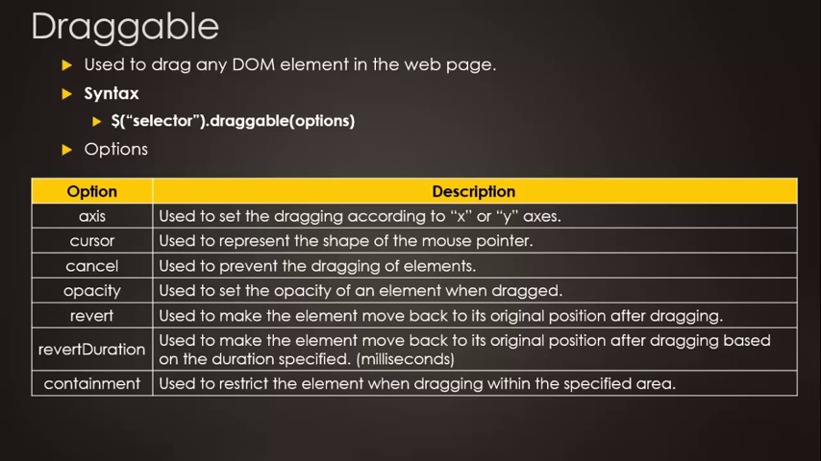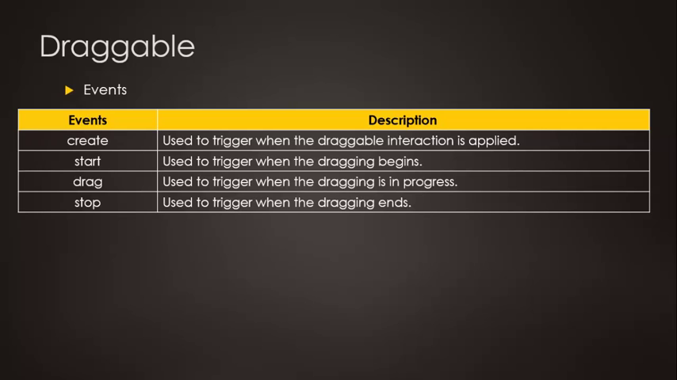

|  |
| --- |
| $(document).ready(funtion()  {$(“h1”).draggable({  axis:”x”,  containment:”h1”,  opacity:0.6,  revert:true,  create:function(){$(“h1”).text(dragabble object created”);},  start:function(){alert(“started dragabble”);},  drag:function(){$(“h1”).text(“dragging under process”);},  stop.function(){$(“h1”).text(“stopped dragging”);}  });}); |

### Droppable: $(“selector”).drobbable(options) used to drop any dom element

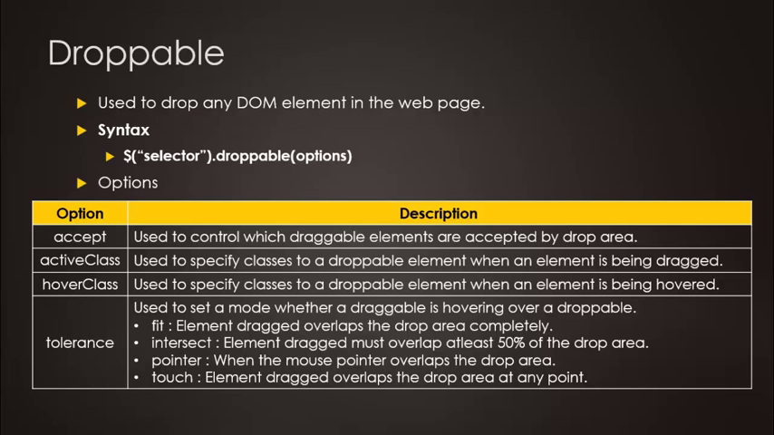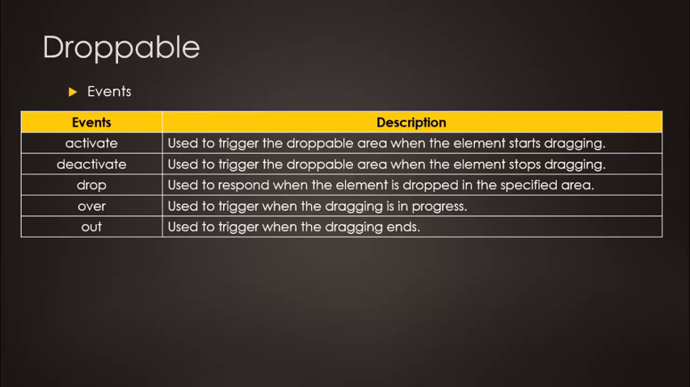

### Resizable: : $(“selector”).resizable(options) used to resize any dom element

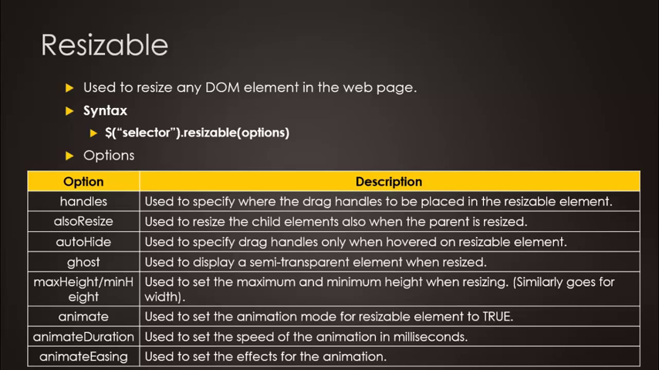

### Selectable: : $(“selector”).selectable(options) used to select any dom element

### Sortable: $(“selector”).sortable(options) used to sort any dom element

## Widgets:

### Accordian

